**Practical No 1**

**Aim:**

**Write a program to compute the following for a given a network: (i) number of edges, (ii) number of nodes; (iii) degree of node; (iv) node with lowest degree; (v) the adjacency list; (vi) matrix of the graph.**

>library(igraph)

>g <- graph.formula(1-2, 1-3, 2-3, 2-4, 3-5, 4-5, 4-6,4-7, 5-6, 6-7)

>plot(g)

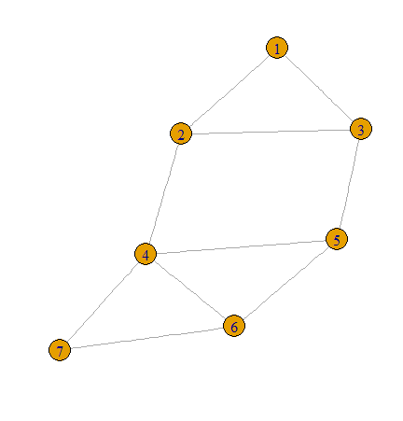

1)number of edges

> ecount(g)

[1] 10

2)no of nodes

> vcount(g)

[1] 7

3)Degree Of nodes

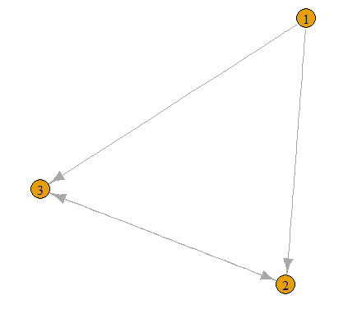

> degree(g)

1 2 3 4 5 6 7

2 3 3 4 3 3 2

> dg <- graph.formula(1-+2, 1-+3, 2++3)

> plot(dg)

> degree(dg, mode="in")

1 2 3

0 2 2

> degree(dg, mode="out")

1 2 3

2 1 1

4) Node with lowest degree

>V(dg)$name[degree(dg)==min(degree(dg))]

[1] "1"

 Node with highest degree

> V(dg)$name[degree(dg)==max(degree(dg))]

[1] "2" "3"

5) To find neighbours / adjacency list:

> neighbors(g,5)

[1] 3 4 6

> neighbors(g,2)

[1] 1 3 4

> get.adjlist(dg)

$`1`

[1] 2 3

$`2`

[1] 1 3 3

$`3`

[1] 1 2 2

6)Adjacency Matrix

> get.adjacency(g)

7 x 7 sparse Matrix of class "dgCMatrix"

1 2 3 4 5 6 7

1 . 1 1 . . . .

2 1 . 1 1 . . .

3 1 1 . . 1 . .

4 . 1 . . 1 1 1

5 . . 1 1 . 1 .

6 . . . 1 1 . 1

7 . . . 1 . 1 .

**Practical No 2**

**Aim:**

**Perform following tasks: (i) View data collection forms and/or import onemode/two-mode datasets; (ii) Basic Networks matrices transformations**

**(i) View data collection forms and/or import one-mode/ two-mode datasets;**

getwd()

[1] "C:/Users/admin/Documents"

> setwd("d:/SNA_pract")

**Reading data from a csv file**

>nodes <- read.csv("nodes.csv", header=T, , as.is=T)



> head(nodes)

Output:-

id media media.type type.label audience.size

1 s01 NY Times 1 Newspaper 20

2 s02 Washington Post 1 Newspaper 25

3 s03 Wall Street Journal 1 Newspaper 30

4 s04 USA Today 1 Newspaper 32

5 s05 LA Times 1 Newspaper 20

6 s06 New York Post 1 Newspaper 50

> links <- read.csv(“edges.csv", header=T, as.is=T)



> head(links)

Output:-

from to weight type

1 s01 s02 10 hyperlink

2 s01 s02 12 hyperlink

3 s01 s03 22 hyperlink

4 s01 s04 21 hyperlink

5 s04 s11 22 mention

6 s05 s15 21 mention

**(ii) Basic Networks matrices transformations**

> net <- graph.data.frame(d=links, vertices=nodes, directed=T)

> m=as.matrix(net)

>get.adjacency(m)

>plot(net)



**Practical N0 3**

**Aim:**

**Compute the following node level measures: (i) Density; (ii) Degree; (iii) Reciprocity; (iv) Transitivity; (v) Centralization; (vi) Clustering.**

**1)Density**

>vcount(g)

[1] 7

> ecount(g)

[1] 10

> ecount(g)/(vcount(g)*(vcount(g)-1)/2)

[1] 0.4719

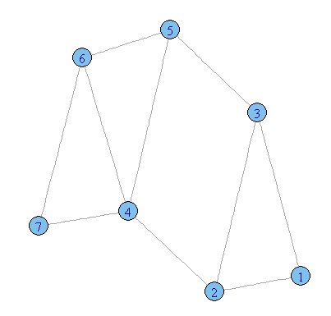

**2) Degree**

> degree(net)

s01 s02 s03 s04 s05 s06 s07 s08 s09 s10 s11 s12

10 7 13 9 5 8 5 6 5 5 3 6

s13 s14 s15 s16 s17

4 4 6 3 5

3) **Reciprocity:**



>dg <- graph.formula(1-+2, 1-+3, 2++3)

>plot(dg)

> reciprocity(dg)

[1] 0.5

* **Formula**

> dyad.census(dg)

$mut

[1] 1

$asym

[1] 2

$null

[1] 0

> 2*dyad.census(dg)$mut/ecount(dg)

[1] 0.5

**4)Transitivity**

> kite <- graph.famous("Krackhardt_Kite")

> atri <- adjacent.triangles(kite)

> plot(kite, vertex.label=atri)

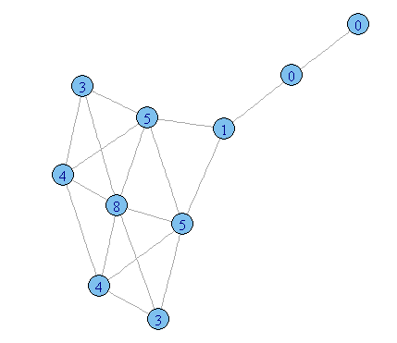

> transitivity(kite, type="local")

[1] 0.6666667 0.6666667 1.0000000 0.5333333 1.0000000 0.5000000

[7] 0.5000000 0.3333333 0.0000000 NaN

**Formula**

> adjacent.triangles(kite) / (degree(kite) * (degree(kite)-1)/2)

[1] 0.6666667 0.6666667 1.0000000 0.5333333 1.0000000 0.5000000

[7] 0.5000000 0.3333333 0.0000000 NaN

**5)Centralization**

* **Degree of centrality**

> centralization.degree(net, mode="in", normalized=T)

* **Closeness Centralization**

> closeness(net, mode="all", weights=NA)

> centralization.closeness(net, mode="all", normalized=T

* **Betweeness Centrality**

> betweenness(net, directed=T, weights=NA)

> edge.betweenness(net, directed=T, weights=NA)

> centralization.betweenness(net, directed=T, normalized=T)

* **Eigenvector centrality**

> centralization.evcent(net, directed=T, normalized=T)

6) **Clustering**

>library(igraph)

# let's generate two networks and merge them into one graph.

>g2 <- barabasi.game(50, p=2, directed=F)

>g1 <- watts.strogatz.game(1, size=100, nei=5, p=0.05)

>g <- graph.union(g1,g2)

#Let's remove multi-edges and loops

>g <- simplify(g)

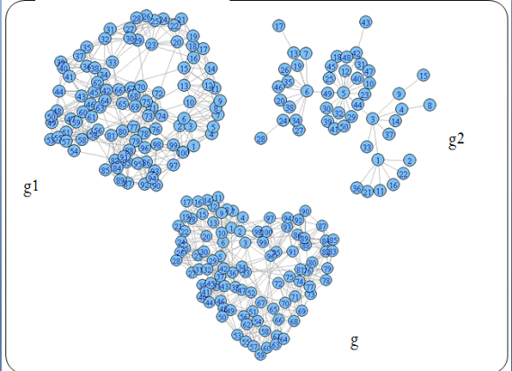

**Practical No 4**

**Aim:**

**For a given network find the following: (i) Length of the shortest path from a given node to another node; (ii) the density of the graph**

**(i) Length of the shortest path from a given**

node to another node;

> library(igraph)

> matt <- as.matrix(read.table(text=

"node R S T U

R 7 5 0 0

S 7 0 0 2

T 0 6 0 0

U 4 0 1 0", header=T))

> nms <- matt[,1 ]

> matt <- matt[, -1]

> colnames(matt) <- rownames(matt) <- nms

> matt[is.na(matt)] <- 0

> g <- graph.adjacency(matt, weighted=TRUE)

> plot(g)

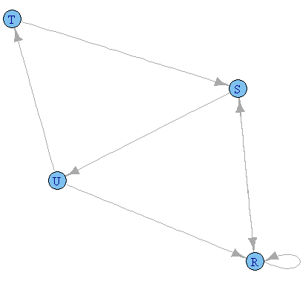

> s.paths <- shortest.paths(g, algorithm = "dijkstra")

> print(s.paths)

R S T U

R 0 5 5 4

S 5 0 3 2

T 5 3 0 1

U 4 2 1 0

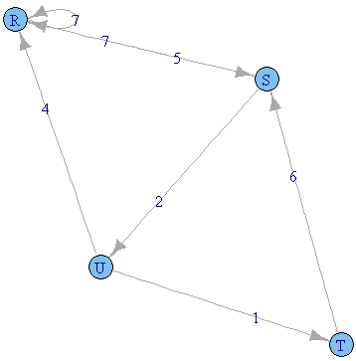

> shortest.paths(g, v="R", to="S")

S

R 5

>plot(g, edge.label=E(g)$weight)

**(ii) the density of the graph;**

> library(igraph)

> dg <- graph.formula(1-+2, 1-+3, 2++3)

> plot(dg)

> graph.density(dg, loops=TRUE)

[1] 0.4444444

* Without considering loops

> graph.density(simplify(dg), loops=FALSE)

[1] 0.6666667

**Practical No 5**

**Aim:**

**Write a program to distinguish between a network as a matrix, a network as an edge list, and a network as a sociogram (or “network graph”) using 3 distinct networks representatives of each.**

**1)a network as a sociogram (or “network graph”)**

> library(igraph)

> ng<-graph.formula(Andy++Garth,Garth-+Bill,Bill-+Elena,Elena++Frank,Carol-+Andy,Carol-+Elena,Carol++Dan,Carol++Bill,Dan++Andy,Dan++Bill)

> plot(ng)

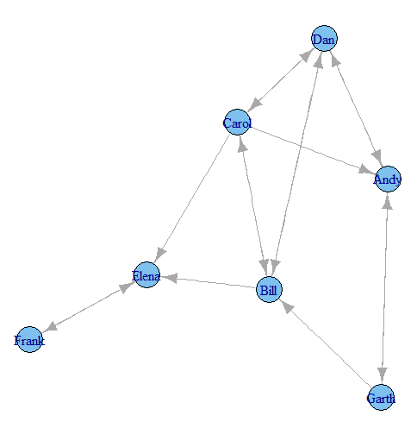

**2) a network as a matrix,**

> get.adjacency(ng)

7 x 7 sparse Matrix of class "dgCMatrix“

Andy Garth Bill Elena Frank Carol Dan

Andy . 1 . . . . 1

Garth 1 . 1 . . . .

Bill . . . 1 . 1 1

Elena . . . . 1 . .

Frank . . . 1 . . .

Carol 1 . 1 1 . . 1

Dan 1 . 1 . . 1 .

**iii) a network as an edge list.**

> E(ng)

Edge sequence:

[1] Andy -> Garth

[2] Andy -> Dan

[3] Garth -> Andy

[4] Garth -> Bill

[5] Bill -> Elena

[6] Bill -> Carol

[7] Bill -> Dan

[8] Elena -> Frank

[9] Frank -> Elena

[10] Carol -> Andy

[11] Carol -> Bill

[12] Carol -> Elena

[13] Carol -> Dan

[14] Dan -> Andy

[15] Dan -> Bill

[16] Dan -> Carol

---get.adjedgelist(ng,mode="in")

$Andy

[1] 3 10 14

$Garth

[1] 1

$Bill

[1] 4 11 15

$Elena

[1] 5 9 12

$Frank

[1] 8

$Carol

[1] 6 16

$Dan

[1] 2 7 13

**Practical No 6**

**Aim:**

**Write a program to exhibit structural equivalence, automorphic equivalence, and regular equivalence from a network.**

1. **structural equivalence**

> library(sna)

> library(igraph)

> links2 <- read.csv(“edges1.csv", header=T, row.names=1)

> eq<-equiv.clust(links2)

> plot(eq)

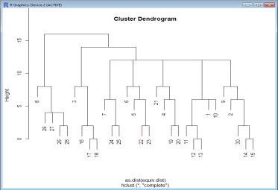

**ii) automorphic equivalence,**

>g.se<-sedist(links2)

 Plot a metric MDS of vertex positions in two dimensions

>plot(cmdscale(as.dist(g.se)))

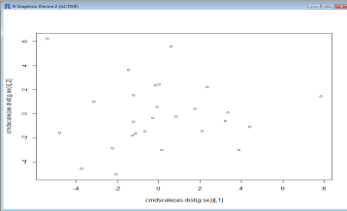

**3) regular equivalence from a network.**

Blockmodeling

> b<-blockmodel(links2,eq,h=10)

> plot(b)

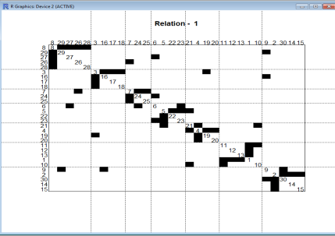

**Practical No 7**

**Aim:**

**Create sociograms for the persons-by-persons network and the committee-bycommittee network for a given relevant problem. Create one-mode network and two-node network for the same.**

>library(Dominance)

>data(data_Network_1)

## set 1 for action you want to show

>bytes= "00111111111000000000"

>Sociogram(data_Network_1,bytes)

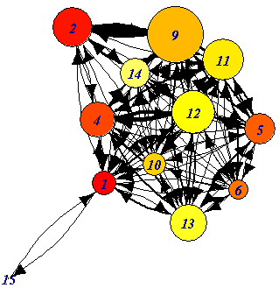 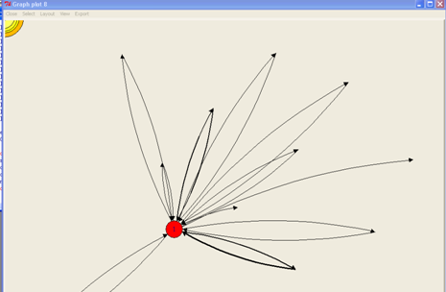 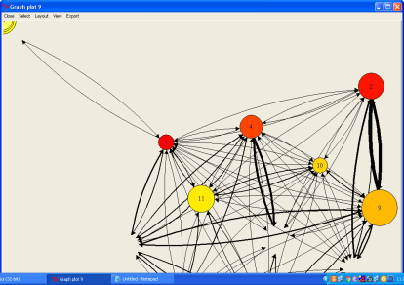

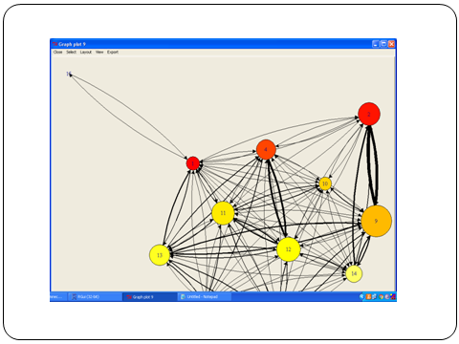 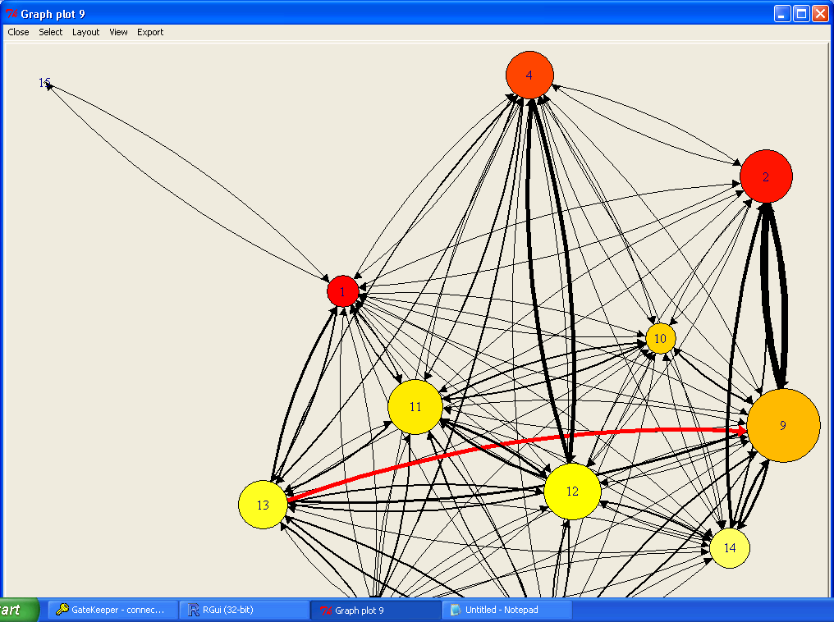

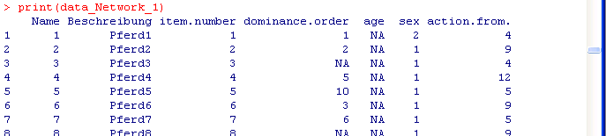

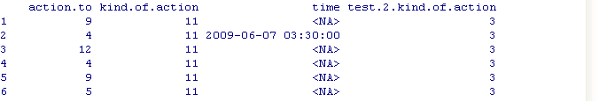

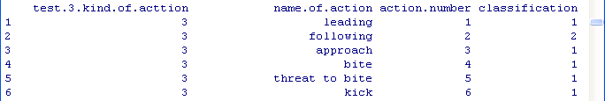

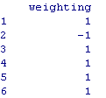

**Practical N0 8**

**Aim:**

**Perform SVD analysis of a network.**

>library(igraph)

>a <- matrix(c(1, 1, 1, 1, 1, 1, 1, 1, 1, 1, 1, 1, 0, 0, 0, 0, 0,

0, 0, 0, 0, 1, 1, 1, 0, 0, 0, 0, 0, 0, 0, 0, 0, 1, 1, 1), 9, 4)

>print(a)

[,1] [,2] [,3] [,4]

[1,] 1 1 0 0

[2,] 1 1 0 0

[3,] 1 1 0 0

[4,] 1 0 1 0

[5,] 1 0 1 0

[6,] 1 0 1 0

[7,] 1 0 0 1

[8,] 1 0 0 1

[9,] 1 0 0 1

> svd(a)

d

[1] 3.464102e+00 1.732051e+00 1.732051e+00 9.687693e-17

 $u

[,1] [,2] [,3] [,4]

[1,] -0.3333333 0.4687136 0.05029703 3.375152e-01

[2,] -0.3333333 0.4687136 0.05029703 -8.126230e-01

[3,] -0.3333333 0.4687136 0.05029703 4.751078e-01

[4,] -0.3333333 -0.2779153 0.38076936 1.160461e-16

[5,] -0.3333333 -0.2779153 0.38076936 1.160461e-16

[6,] -0.3333333 -0.2779153 0.38076936 1.160461e-16

[7,] -0.3333333 -0.1907983 -0.43106639 -7.755807e-17

[8,] -0.3333333 -0.1907983 -0.43106639 -7.755807e-17

[9,] -0.3333333 -0.1907983 -0.43106639 -7.755807e-17

$v

[,1] [,2] [,3] [,4]

[1,] -0.8660254 -2.464364e-17 0.00000000 0.5

[2,] -0.2886751 8.118358e-01 0.08711702 -0.5

[3,] -0.2886751 -4.813634e-01 0.65951188 -0.5

[4,] -0.2886751 -3.304723e-01 -0.74662890 -0.5